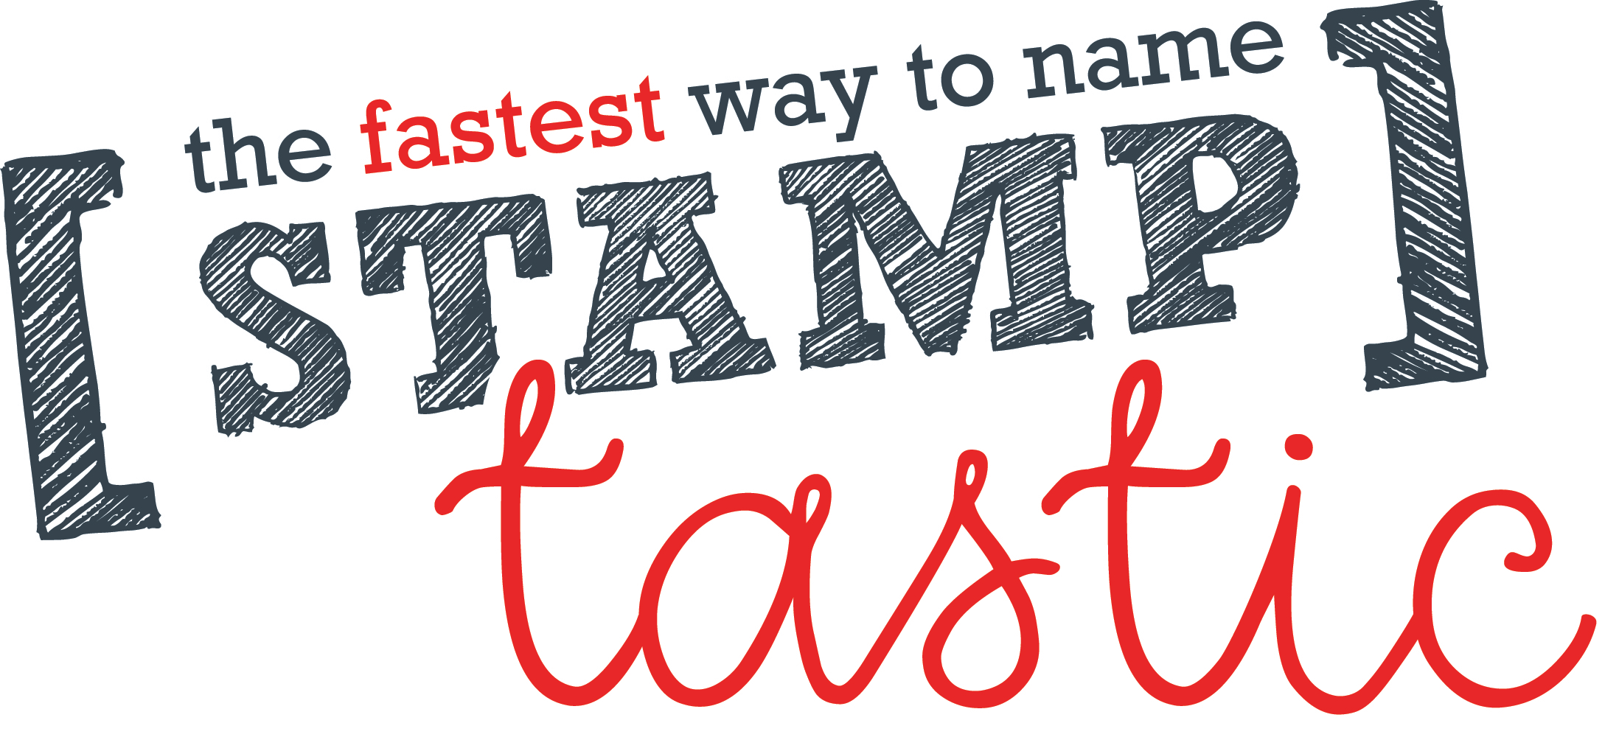

Use the code TOWERHOUSE online to earn 20-30% commission for Tower House School!!
www.stamptastic.co.uk

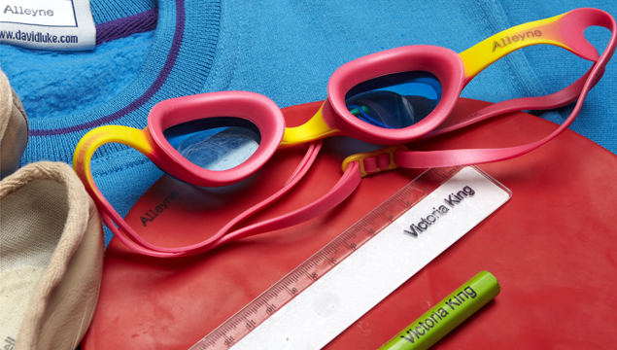

Love it? Stamp it! Keep it!

A new fast way of naming all your belongings!
A personalised stamp, usable on fabric, metal, wood & most plastic.
No more sewing or ironing on labels.
No more losing your pencil case or P.E. kit!
Now you can just stamp everything!

Transparent block for accurate, easy positioning.
The ink will last wash after wash.
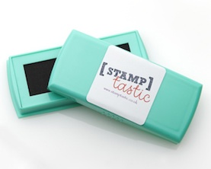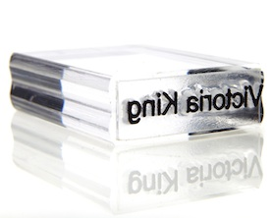
One ink-pad £12 each One stamp £10 each
Bottom of Form

Email: orders@stamptastic.co.uk
www.stamptastic.co.uk
020 8332 9781
Stamptastic Ltd: Company No: 07506214

